32.46: 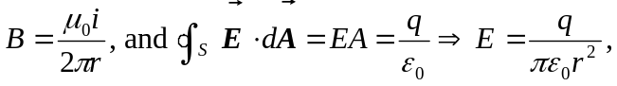 so the magnitude of the Poynting vector is 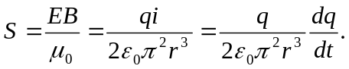
Now, the rate of energy flow into the region between the plates is:
This is just rate of increase in electrostatic energy U stored in the capacitor.

